Linear Regression: Training vs Testing
Lab Report #5

Sharrena Mae B. Camus (11227427)  shane_camus@yahoo.com | John Elijah B. Santos (11224436)  jebssantos@gmail.com
Angelica Grace D. Terrado(11235322)
angelica_terrado@dlsu.edu.ph

- ABSTRACT

Linear Regression is useful tool in machine learning to predict the output. This laboratory activity focuses on predicting the house price given an actual data to train by using the linear regression.

- INTRODUCTION

Although this is mainly referred to as a common statistical method, Linear Regression is one of the firstly introduced methods of evaluating data sets for Machine Learning. The main objective of Linear Regression in Machine Learning is to enable the machine to intelligently guess certain values with respect to predetermined features, based on an already established set of data. When graphed, the line would portray the relationship between certain values and the features as variables, in way that would be best fit for the entire data set, this line would be called the regression line, which can be described by the well-known mathematical equation “y = mx + b”, the slope-intercept form of a line. The function that is used to evaluate the data is called the hypothesis function. The data set must be analyzed closely in order to observe the relationship between the variables and the corresponding error that would come along with it. To find out the error and minimize it as much as possible, minimization algorithms such as differentiation and Gradient Descent are used. These algorithms evaluate a so called cost function by taking the values of the data set repeatedly and applying calculus in order to minimize the errors. Despite these function minimization algorithms, the resulting regression line is still much dependent on the initial data itself. Cases in which the regression line does not suffice for all the data values and would involve large error is called Underfitting which can be observed in Fig. 1, while a case in which the data would involve noise and would cause unnecessary, erratic curves in the graph is called Overfitting which can be seen in Fig. 2.
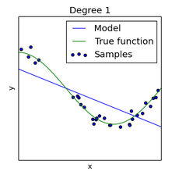
Fig. 1 Underfit Regression Line
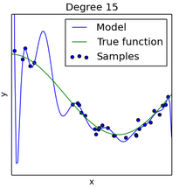
Fig. 2 Overfit Regression Line

- OBJECTIVES
- To be able to implement linear regression and gradient descent algorithm from a given set of data
- To be able to predict a dependent variable by utilizing the implemented model

- EXPERIMENT
1. Add necessary details in the linear_regression.m
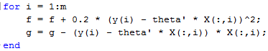
2. Run the ex1a_linreg.m

- DATA AND RESULTS

1. Plot the predictions on the actual data..
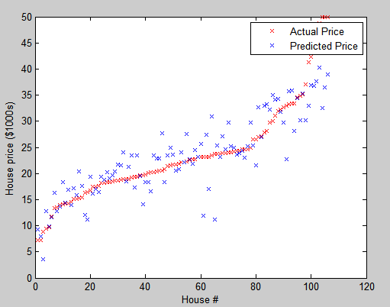
Fig. 1. Resulting Plot
2. 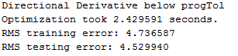

- ANALYSIS AND CONCLUSION

Based from the data, the machine were able to learn and predict the probable prices of the houses. It is obtained by getting the cost function and the gradient of the data. These two have a lot of effect in predicting data. Also, codes needs to be tested and optimized by getting its RMS or the root-mean-squared. Without it, the RMS error is huge and it can’t predict data very well.
After putting the necessary codes, the RMS was minimized and the optimization time was fast.

[1] K. Bartocha, 'Linear Regression vs Logistic Regression vs Poisson Regression | Marketing Distillery', Marketingdistillery.com, 2015. [Online]. Available: http://www.marketingdistillery.com/2014/11/23/linear-regression-vs-logistic-regression-vs-poisson-regression/. [Accessed: 23- Sep- 2015]. (http://onlinestatbook.com/2/regression/intro.html)
[2] A. Ng, 'Machine Learning', Openclassroom.stanford.edu, 2015. [Online]. Available: http://openclassroom.stanford.edu/MainFolder/DocumentPage.php?course=MachineLearning&doc=exercises/ex4/ex4.html. [Accessed: 23- Sep- 2015].
[3] F. Schoonjans, 'Logistic regression', MedCalc, 2015. [Online]. Available: https://www.medcalc.org/manual/logistic_regression.php. [Accessed: 23- Sep- 2015].
[4] C. Shalizi, Advanced Data Analysis from an Elementary Point of View, 1st ed. Cambridge University Press, 2015, p. 223.
[5] Stat.yale.edu, 'Linear Regression', 2015. [Online]. Available: http://www.stat.yale.edu/Courses/1997-98/101/linreg.htm. [Accessed: 23- Sep- 2015].

